SW Engineering CSC648/848

RetroHub

Section 01 Team 04

Ysidro Alfaro De Leon - Team Lead

Jhon Raimund Aclan - Front End Lead

Jason Chan - Back End Lead

Deep Dhorajiya - Scrum Master

Om Dankhara - Github Master

September 27, 2023

| Milestone 1: | 9/27/2023 |
| --- | --- |
| Milestone 2: | 10/11/2023 |
| Milestone 3: |  |
| Milestone 4: |  |
| Milestone 5: |  |

Table of contents

**1. Executive Summary 2**

**2. Personas and User Stories 2**

Use Case 1: User-Generated Content 2

Use Case 2: Game Headlines 2

Use Case 3: Game deals and discount 3

Use Case 4: Game guides, tips, and tricks 3

Use Case 5: Game Matchmaking 3

**3. Data Definitions 3**

**4. Initial list of functional requirements 5**

**5. List of non-functional requirements 6**

1. Performance 6

2. Scalability 6

3. Availability 6

4. Security 6

5. Usability 6

6. Accessibility 6

7. Reliability 6

8. Maintainability 6

9. Data Integrity 6

**6. Competitve analysis 6**

**7. High-level system requirements 7**

**8. Team 8**

**9. Checklist 8**

# Executive Summary

In today’s digital age, the gaming industry keeps flourishing, with no signs of a slowdown in the near future. Gamers from all platforms, exploring worlds in RPGs or competing in multiplayer battles, there’s something out there for everyone that has caught the interest of millions all over the world. Regardless of the bloom of gaming, a lot of people still find themselves feeling alone in their gaming activity. Some wish they could have an outlet to share the glorious moments of their session, find other players that they can connect to who also love the games they play, or simply stay up to date with the gaming world. Of course, there are some platforms out there that can provide gamers some comfort, but there really isn’t a reliable hub for gamers to connect and get the latest gaming news (biased and unbiased). This provides an opportunity to create a platform that could provide this and more to users.

Welcome RetroHub, our innovative gaming blog app. RetroHub wants to be the go-to place for gamers, giving them a forum where they can not only read about the newest titles but also have in-depth conversations with other players. As opposed to other platforms, RetroHub concentrates on building a community where players can exchange opinions, game tips, and reviews. We place a high value on honest, truthful information that appeals to both casual and die-hard players. Additionally, our user-friendly layout guarantees a flawless surfing experience, enabling users to explore their passions for gaming in greater depth.

Our team is a group of dedicated students who understand the gaming community because we are gamers. We know how annoying it is that there is no dedicated community for gamers where people can blog about their progress and journey as gamers. With our skills in computer science, and technology and a passion for gaming, we will work on this student start-up diligently and passionately.

# Personas and User Stories

## Use Case 1: User-Generated Content

Carmen is a 25-year-old streamer with 10,000 viewers daily, who has his stream up for ~10 hours a day where he plays a variety of games. Carmen can use this site as a “highlight reel” where he posts content such as clips from his stream of awesome gameplay moments and funny reactions, and his viewers can comment and rate his content.

## Use Case 2: Game Headlines

Laurel, a gamer, is looking for the most up-to-date information about new game releases for the coming year. Our gaming platform website provides Lauel with real-time updates on game-related news stories. He can navigate and explore numerous content connected to gaming platforms such as Console, PC, and Mobile with ease. The platform's main Headline page may have a prominent "Spotlight" section that spotlights notable gaming headlines on a continual basis. Laurel can sort articles by popularity, controversy, recency, and age while browsing the site. After reviewing the articles, Lauel can participate further by viewing, posting, and rating comments on each post. By enabling discussion and feedback on the gaming stories, this feature improves the user's interactive experience. This use case describes Lauel's journey across our gaming platform, where he can remain up to date on gaming news, engage with the community, and access a wide choice of gaming content.

## Use Case 3: Game deals and discount

Jacob is always on the lookout for the best game deals and discounts. Our platform can help Jacob scroll around game deals that offer real-time updates and various game deals with notifications on the deals and discounts tab.

Behavior: Always on the lookout for the best game deals and discounts.

Interests: Finding the most cost-effective way to enjoy a variety of games.

Skills: Excellent at tracking down deals, price comparison, and patience in waiting for discounts.

Pain Points: Missing out on great deals, dealing with expired promotions, and struggling to find reliable sources for game deals.

## Use Case 4: Game guides, tips, and tricks

Marco is currently playing an open-world game with many places to explore and find weapons and gear in order to defeat various enemies within the game. Using this site, he can look up any potential guides on how to find a specific item with detailed steps on how to do so, or an extensive list of tips that help in defeating a really challenging boss.

## Use Case 5: Game Matchmaking

Jennifer is a 28-year-old casual gamer who does not have many gamer friends. She enjoys games on her Nintendo Switch where she enjoys multiplayer-based games. Using this site, Jennifer can look up the game and the community in that game and platform to meet new gamer friends who enjoy playing the same Nintendo Switch games she does.

III. UI Mockups and StoryBoards

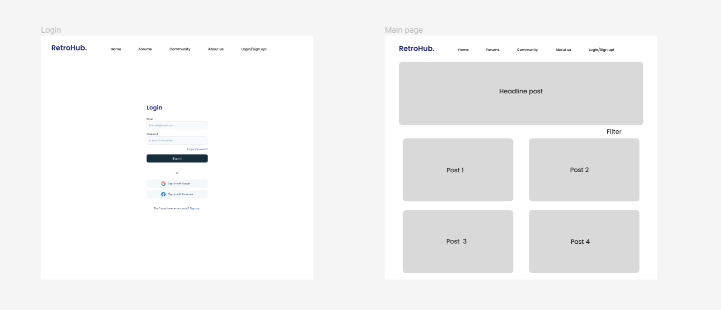

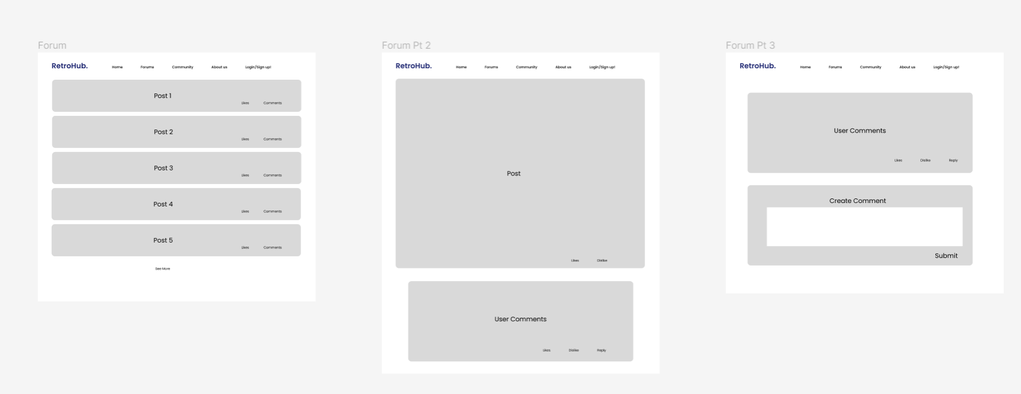

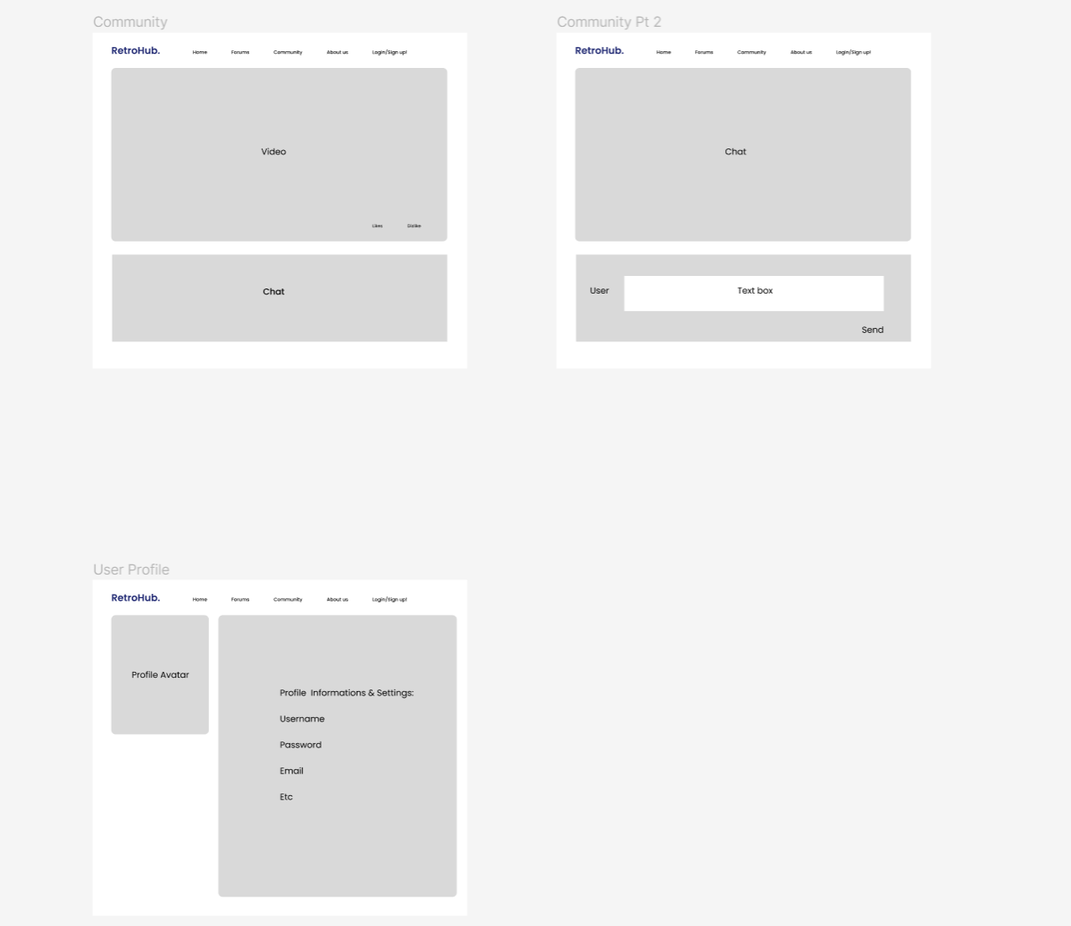

# Data Definitions

| **Primary Data Name** | **Definition** | **Usage** |
| --- | --- | --- |
| Post | Can be a post, article, guide, etc | Contains content that site users will view |
| Registered_User | User who is registered and signed on to the site. | Registered users can use the site and browse site features |
| Comment | A comment that a user leaves on a post | A form of feedback and engagement that a user provides on a post |
| Event | An announcement of an event such as tournaments or contests, etc. | These events will be presented to users in a dedicated events tab? |
|  |  |  |

| **Primary Data Name** | **Sub Data** |
| --- | --- |
| Post | * Post_id * Post_name * Post_datetime * Post_type * Post_content * Post_genre * Post_likes * post_dislikes * Post_game |
| Registered_User | * User_id * Date_registered * Date_lastlogin * User_name * User_image * User_password * User_email |
| Comment | * Comment_id * Comment_date * Comment_time * Comment_content * Comment_rating |
| Event | * Event_id * Event_name * Event_Start_date * Event_Start_time * Event_End_date * Event_end_time * Event_content |

# Initial list of functional requirements

| **ID:** | **Function Requirement** | **Details** | **Priority** |
| --- | --- | --- | --- |
| 1 | Users | 1.1 Users shall be able to view articles, posts, guides, etc | High |
|  | 1.2 Users shall be able to make comments on articles, posts, guides, etc. | High |
|  | 1.3 Users shall be able to upvote or downvote comments or articles, posts, guides, etc | Medium |
|  | 1.4 The site must make it available to all users with all comments on an article, post, guide, etc. | Medium |
|  | 1.5 Users shall be able to view deals and discounts on different games. | High |
| 2 | Post Management | 2.1 Authorized users shall be able to post gaming articles. | High |
|  | 2.2 Authorized users shall be able to update or delete existing articles | High |
| 3 | Real-Time Updates | 3.1 The site shall be able to check for new updates and display them. | Medium |
|  | 3.2 The site shall update users on new articles based on their preferences and interactions. | Medium |
| 4 | Search & Filtering | 4.1 Users will be able to sort post based on popularity, controversy, recentness, and age. | High |
|  | 4.2 The site should have filters for viewing content pertaining to specific gaming platforms (Console, PC, Mobile). | High |
|  | 4.3 Users shall be able to look for content based on keywords or phrases. | Medium |
|  | 4.4 Users shall be able to view relevant search results based on their search query. | Medium |

# List of non-functional requirements

## Performance

* 1. The pages shall load within 2 seconds.
  2. Any articles, comments, ratings should load with a delay of 3 seconds
  3. Any clips or video should load with a delay of 4 seconds.

## Scalability

* 1. The site shall be responsive for both mobile and pc.
  2. The site shall be able to handle capacity of users up to 2,000.

## Availability

* 1. The site shall be able to provide real-time updates.
  2. The site shall have an uptime of 99.9% of the time

## Security

* 1. The site shall be able to store user information and data.

## Usability

* 1. Users are able to easily navigate through articles/posts

## Accessibility

* 1. the site will be using colors that are UX friendly to people who may be colorblind

## Reliability

* 1. The site shall be able to recover from any failures.

## Maintainability

* 1. The site shall be able to be easily modified for any updates.

## Data Integrity

* 1. The site shall be able to maintain records of user information.
  2. The site shall be able to maintain record of any user interactions.

# Competitve analysis

We will be comparing our website with the community section of the popular Steam platform.

Example: <https://steamcommunity.com/>

| Steam | Planned Features |
| --- | --- |
| 1) Anything with high engagement will automatically be at the top | 1) Same principle but with more of a focus on posts/articles? |
| 2) Steam News Hub includes a section for upcoming, today, and coming soon articles. | 2) Our site will have a main headline page that will display any gaming articles. This headline page will also showcase a “spotlight” page to show popular articles. |
| 3) Steam community includes a share button that shares the recent article that connects to social media platforms. | 3) We will have the option to share as well, in the blog community, the UX flow will be much better than the one provided in Steam. |
| 4) Has individual community pages per game | 4) we can set a filter on posts per game? |

Compared to current platforms like Steam, our new gaming blog platform is painstakingly developed to improve user engagement and pleasure. While Steam favors material with high levels of engagement, our site improves on this strategy by putting a special emphasis on interesting posts and articles, making sure that good content is readily available and clearly displayed. In contrast to Steam's News Hub, our platform has a streamlined headline page that highlights a "spotlight" area that highlights popular stories and promotes a richer user experience while still displaying gaming-related news. Sharing is simplified; while Steam has a share button, our website raises this function by providing a better UX flow in the blog community, making content sharing simple and uncomplicated. We also plan to incorporate individualized post filters per game, allowing users to tailor their content experience uniquely, thus, providing a more personalized and user-centric environment than the Steam community.

# High-level system requirements

* 1. MERN stack (MongoDB, React, Node.js, Express)
  2. Works on chrome, firefox, edge, safari.
  3. List of usable APIs <https://github.com/public-apis/public-apis>:
     1. Gamine APIs: <https://rapidapi.com/category/Gaming>
     2. IDGB API - Video Game Database: <https://api-docs.igdb.com/>
     3. Bater.VG - Provides information about Game, DLC, Bundles, Giveaways, Trading - <https://github.com/bartervg/barter.vg/wiki>
     4. Cheap shark - Steam/PC Game Prices and Deals: <https://apidocs.cheapshark.com/>

1. High-Level Architecture + database

Post

| Post |
| --- |
| post_id int PK |
| post_name varchar(255) |
| post_type varchar(255) |
| post_datetime timestamp |
| post_content array |
| post_likes int |
| post_dislikes int |
| post_game int |

User

| registered_user |
| --- |
| user_id int PK |
| user_name varchar(255) |
| user_password varchar(255) |
| date_registered timestamp |
| date_lastlogin timestamp |
| user_image varchar(255) |
| user_email varchar(255) |

1. **Identify actual key risks for your project at this time**

**Skills Risks and Mitigation Plan:**

**Risk:** There is a risk that our team might not possess all the necessary technical skills required for the project.

**Mitigation Plan:**

To address this, we have a study plan in place to ensure that team members have access to relevant training and resources to cover any skill gaps. We are actively encouraging team members to engage with each other and watch tutorials to enhance their skills.

**Schedule Risks:**

**Risk:** Our team may face scheduling conflicts and uncertainty regarding individual tasks.

**Mitigation Plan:** We have established a detailed team schedule that allocates tasks to each member, ensuring clarity on responsibilities and deadlines. We are using a discord to manage tasks and updates transparently. In case of schedule changes, we will promptly update on the channel to reflect the changes and keep everyone informed.

**Teamwork Risks:**

**Risk:** There is a potential risk of irregular team meeting attendance and differing paces among team members.

**Mitigation Plan:** We are committed to regular team meetings with scheduled agendas to ensure everyone's participation. Additionally, we discuss in detail what to be done next, how to manage tasks and provide support when needed. This plan will help mitigate any teamwork-related risks.

**Legal/Content Risks:**

**Risk:** Obtaining content and software legally with proper licensing and copyright compliance might be a challenge.

**Mitigation Plan:** We are proactively researching and documenting the licensing and copyright requirements for all the content and software we intend to use. We will ensure that all necessary licenses are obtained, and the copyright issues are resolved before incorporating any content into the project. This proactive approach will help us mitigate any legal and content-related risks.

# Team

* 1. Ysidro Alfaro De Leon - Team Lead
     1. Will work on use case 5
     2. Worked on Executive Summary Paragraphs
  2. Jhon Raimund Aclan - Front End Lead
     1. Worked on use case 2
     2. Worked on list of non-functional requirements
     3. Worked on adding #2 of the Competitive analysis.
     4. Added stuff on high-level system requirements.
  3. Jason Chan - Back End Lead
     1. Worked on cases 1 and 4
     2. High-level architecture and database
     3. Express api
  4. Deep Dhorajiya - Scrum Master

i. Worked on use case 3.

ii. Actual key risks

* 1. Om Dankhara - Github Master

Worked on use case 5.

# Checklist

1. Team found a time slot to meet outside of the class: **DONE**

2. Scrum Master shares meeting minutes with everyone after each meeting. **DONE**

3. Github master chosen: **DONE**

4. Everyone sets up their local development environment from the team’s git

repo. **DONE**

5. Team decided and agreed together on using the listed SW tools and

deployment server **DONE**

6. Team ready and able to use the chosen back/front-end frameworks. **DONE**

o For each technology (front/back-end/DB/cloud) , team decides who will

lead the study of each technology and what will be the specific goal of the

study within one month from the M1 announcement. **DONE**

Ex : implement DB scheme for main data items

o If you list a detailed study plan for this, earn extra points!

7. Team lead ensured that all team members read the final M1 and

agree/understand it before submission **DONE**

1. Team Management

Our project team is made up of talented people, each of whom contributes significantly to the project's progress in a variety of ways. In order to ensure consistency with underlying operations and data processes, our front-end lead collaborates closely with the back-end team while designing an intuitive and captivating user experience.

We regularly meet for an hour on Wednesdays to monitor our progress, plan for upcoming responsibilities, and work together to address new obstacles. These meetings have been helpful in promoting open communication and teamwork among team members. Our main platform for constant communication and teamwork is Discord, which makes sure that every member is informed and actively involved.

As team leader, it is my responsibility to monitor the project's overall progress and make sure that each member has the resources they need to complete their tasks. In order to improve our workflow and task management even more by providing clearer visibility of each task's status and the accountable team member, we are looking to communicate more and build a better community for the team as a whole to support and help each other as we continue to develop RetroHub.